**Experiment No: 06**

Title: Running php application and MySQL server over the docker.

Aim: To run the php application and MySQL server over the docker.

Theory:

Container technology is growing every day. It’s a technology that makes application development much easier and faster. It has a clean architecture that ensures application services utilize resources sustainably by dividing an application into smaller services called images. This allows you to set up each service independently without affecting how the other services run.

In this case, Docker provides a docker-compose file that allows you to set all your application environments and run a few commands to fully set up your application in a more elegant and faster approach.

Let’s take the case of running a PHP application. You would have to install all environments that you need to run PHP scripts. You need an apache server installed in your server/system and probably a MySQL database. Then set up each environment in a way that will allow you to run your PHP-driven website.

With Docker, things are much more manageable. Docker allows you to set your application with each service running as a microservice. This way, you set a single YML file that will isolate all the services that your application needs to run. The file sets up the PHP Apache server and MySQL database for you. All you need is to specify the parameters that you need your application to run on.

The main advantage that Containers provides, is a scalable environment to run your application services. It ensures that the practices of continuous integration and continuous delivery (CI/CD) pipelines are enhanced across the team. So you only need to share this YML file with every team member. This will set all the necessary environments across the team regardless of the operating system they are running on. Thus team members can synchronize their work without breaking the code.

This guide will show you how we can use Docker development environment to:

Setup and run a local PHP Apache server instance.

Serve a dynamic PHP-driven website.

Setup a MySQL database to run SQL scripts, fetch records, and print them in a PHP-driven website.

We will use the Docker hub images to set up a containerized PHP development environment.

Prerequisites

* Ensure that Docker demons are installed on your computer.
* Basic knowledge of PHP and SQL queries.
* Fundamental understating of how to build and run Docker hub images from a Docker file.
* Understand how containers work.
* Basic knowledge on how to execute Docker and docker-compose commands.

Practical:

To set a docker-compose, you need first to select the [Docker version](https://docs.docker.com/compose/compose-file/compose-versioning/#compatibility-matrix) you want to use, the services you want to provide, and the containers you want to run.

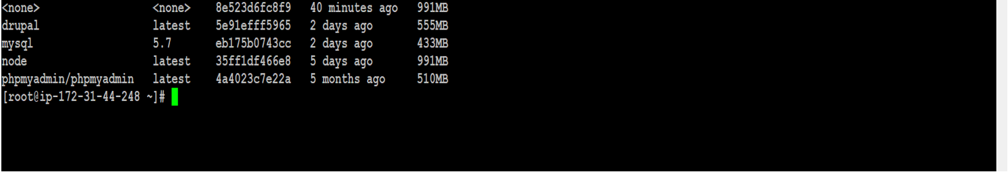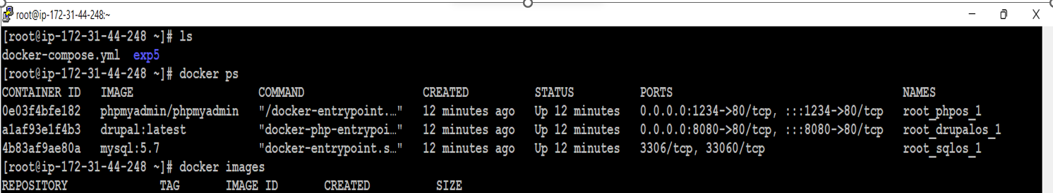

pen http://localhost:8080/ on the browser to access the PHPMyAdmin.

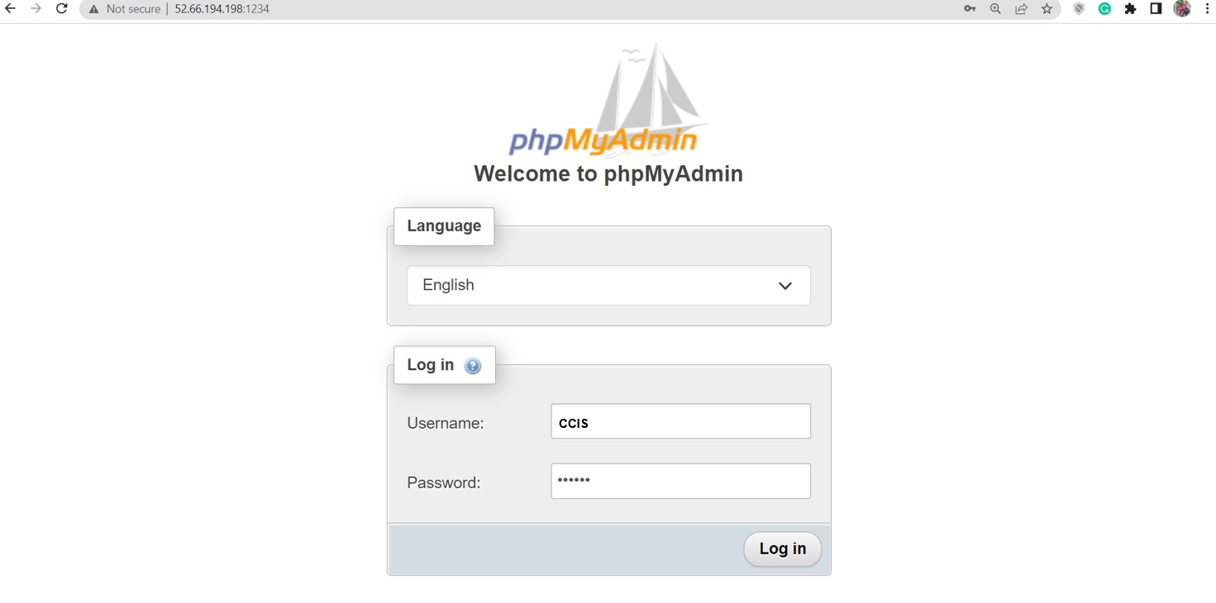



To login to the Phpmyadmin panel, use username as root and password as MYSQL_ROOT_PASSWORD. The password was already set in the MySQL environment variables (MYSQL_ROOT_PASSWORD: MYSQL_ROOT_PASSWORD)



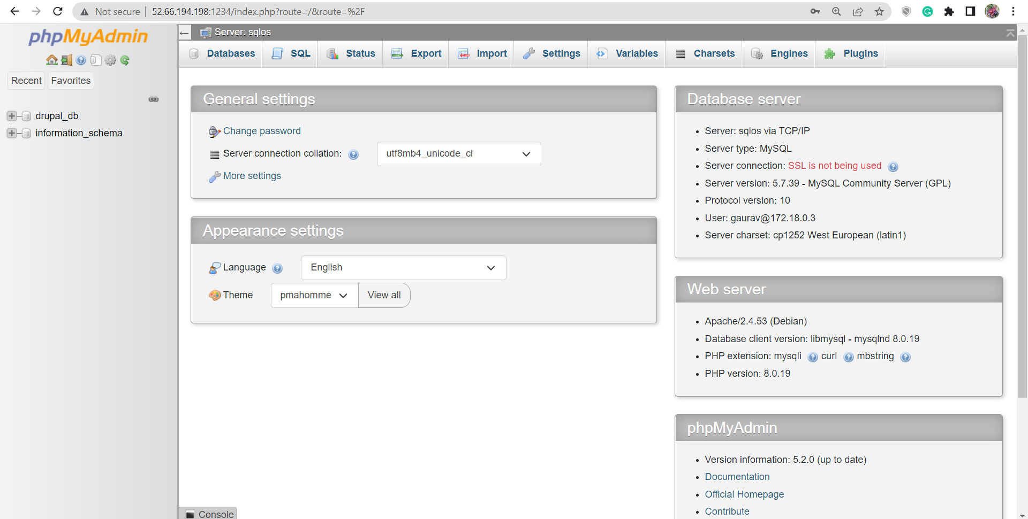

You can now see the database we defined is already set as MYSQL_DATABASE, and you can start interacting with Phpmyadmin.

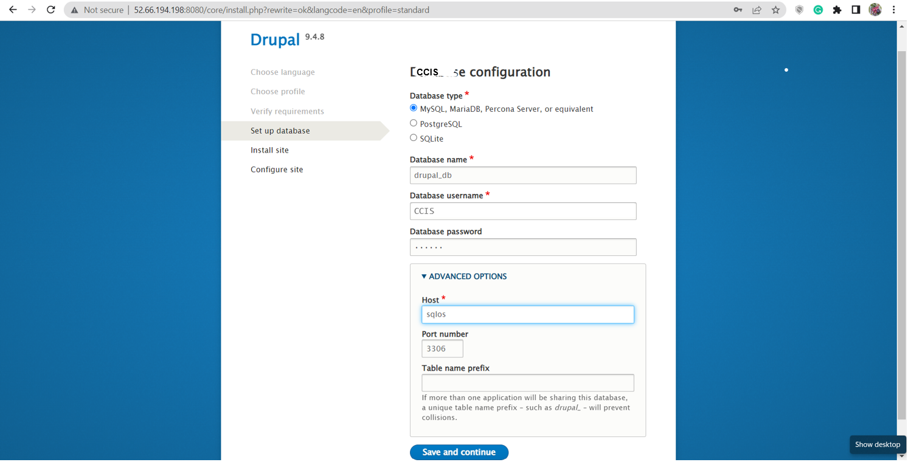

Conclusion: Thus I have successfully executed php application and MySQL server on docker.